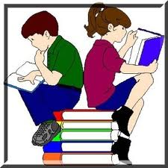
Hello,
We are at the end of another great year at Matthews Elementary. Our students will go home…only to enjoy the sun, the beach, enjoy family and friends, and all that the summer break entails. And in between all that fun, hopefully, they will read a book.
So, to encourage summer reading, Matthews Elementary will launch a new reading campaign in the fall called, “Matthews Readers.” We plan to encourage each child to keep a log of how many books he/she reads in a month, and have prizes and treats to give to the highest boy and highest girl per grade level. A book will be provided to start their summer reading.
Right now, books are available to give each child who would like to participate in this program. The book will be free to the child, to own and to cherish. This book can be the first book to be listed on the Matthews Readers log.
If you are interested in participating, please fill out the form below and return to your child’s teacher by Thursday, May 17th. In turn, your child will receive an age-appropriate book and a reading log.
Please continue to encourage your child to read, because "To learn to read is to light a fire; every syllable that is spelled out is a spark." ~Victor Hugo, Les Miserables
Please encourage your child to participate.
Thank you, and have a safe and fun summer!
---------------------------------------------------------------------------------------------------------
Student’s name_________________________ Teacher__________________

